**PROJECT REPORT**

on

*Trip Based Modelling of Fuel Consumption in Modern Fleet Vehicles Using Machine Learning*

**Submitted by:**

*Attaluri Harshitha (20BCI7227)*

*Pallabothu Bhavya Sri Lakshmi Sravanthi (20BCI7225)*

*Zoya Fatima (20BCE11102)*

*Karakkayala Sravan Sai Kumar (20BCE2659)*

**Submitted to:**

*SmartBridge Applied Data Science*

**Contents**

1. Introduction

1.1 Overview………………………………………….

1.2 Purpose……………………………………………...

2. Literature Survey

2.1 Existing problem………………………………………….

2.2 Proposed solution ……………………………………………...

3. Theoretical Analysis

3.1 Block Diagram………………………………………….

3.2 Hardware/Software ……………………………………………...

4. Experimental Investigations

5. Result

6. Advantages and Disadvantages

7. Applications

8. Conclusion

9. Future Scope

10. Bibliography

**1. INTRODUCTION**

**1.1 Overview**

The transportation industry heavily relies on fleet vehicles to meet the growing demands of logistics and transportation services. However, the fuel consumption of these vehicles poses a significant challenge for fleet managers. Inefficient fuel usage not only leads to higher operational costs but also has adverse environmental impacts, including increased carbon emissions and pollution. To address this problem, accurate estimation and prediction of fuel consumption based on trip characteristics are crucial for optimizing fleet operations and promoting sustainability.

The project "Trip Based Modeling Of Fuel Consumption In Modern Fleet Vehicles Using Machine Learning" aims to develop a robust and accurate predictive model that estimates fuel consumption for fleet vehicles based on trip parameters. By leveraging machine learning techniques, specifically linear regression, this project offers a data-driven approach to understand and analyze the relationship between various trip factors and fuel consumption. The developed model can provide fleet managers with valuable insights and predictions, enabling them to make informed decisions for optimizing fuel efficiency and reducing operational costs.

**1.2 Purpose**

The purpose of this project is to provide fleet managers with a practical tool that can accurately estimate and predict fuel consumption based on trip characteristics. By utilizing machine learning algorithms, the model can analyze historical trip data and learn the patterns and correlations between different trip parameters and fuel consumption. This understanding allows fleet managers to identify the key factors influencing fuel consumption and take proactive measures to optimize their fleet operations.

Through the integration of the developed model into a web application using Flask, fleet managers can conveniently access and utilize the fuel consumption prediction functionality. This user-friendly interface enhances the practicality and usability of the model, making it accessible to a wider range of users within the fleet management ecosystem.

The ultimate goal of this project is to contribute to the development of more sustainable and cost-effective fleet operations. By accurately estimating fuel consumption, fleet managers can optimize vehicle routing, maintenance schedules, and fuel procurement strategies, leading to reduced costs, minimized environmental impact, and improved overall efficiency of fleet operations.

**2. LITERATURE SURVEY**

**2.1 Existing problem**

The efficient management of fuel consumption in fleet vehicles has been a persistent challenge for fleet managers. Traditionally, fleet managers have relied on manual data collection methods and simplistic calculations based on average fuel economy figures. However, these approaches lack accuracy and fail to account for the diverse factors that influence fuel consumption, such as trip characteristics, driving conditions, and vehicle specifications.

To address these limitations, researchers and practitioners have explored various approaches to modeling and predicting fuel consumption in fleet vehicles. Some studies have focused on statistical modeling techniques, such as multiple regression analysis, to identify the key factors affecting fuel efficiency. These studies often consider variables such as vehicle weight, engine size, and road type. While these approaches provide valuable insights, they may not capture the complexities and interactions between multiple variables.

**2.2 Proposed solution**

In this project, we propose the use of machine learning techniques, specifically linear regression, to develop a more accurate and data-driven model for estimating fuel consumption in modern fleet vehicles. By leveraging historical trip data, the model can learn from patterns and correlations between trip characteristics and fuel consumption. This approach allows for a more comprehensive understanding of the complex relationships between variables.

Machine learning-based approaches offer several advantages over traditional methods. They can handle large and complex datasets, incorporate a wide range of variables, and adapt to changing patterns and conditions. By training the model on a diverse set of trips, it can capture the nuanced effects of different factors, such as distance, speed, road conditions, and vehicle specifications, on fuel consumption. Additionally, the model can continuously learn and improve over time as more data becomes available.

The integration of the model into a web application using Flask further enhances its usability and accessibility. Fleet managers can conveniently access the application through a web browser, input trip parameters, and receive fuel consumption predictions in real-time. This integration simplifies the process of utilizing the model's capabilities and empowers fleet managers to make data-driven decisions for optimizing fuel efficiency.

Through this proposed solution, fleet managers can overcome the limitations of traditional approaches and gain valuable insights into fuel consumption patterns. This, in turn, enables them to implement targeted strategies for reducing fuel costs, minimizing environmental impact, and improving overall fleet management efficiency.

**3. THEORETICAL ANALYSIS**

**3.1 Block diagram**

Sensor Inputs  
(sensors in the vehicles that capture speed, temperature, acceleration etc.…)

Cleaning the data  
normalization  
feature extraction  
handling the null values

Data Preprocessing

Machine learning model  
Linear Regression

Feature Engineering  
(transforms the preprocessed data into a set of meaningful features)

Model Evaluation

Model Training

Fuel consumption prediction

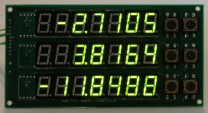

Post-Processing

**3.2 Hardware / Software designing**

To implement the project, the following hardware and software requirements were identified:

- Hardware:

- Fleet vehicles equipped with telematics devices or data loggers to capture trip data.

- Server or cloud infrastructure for data storage and processing.

- Software:

- Programming language: Python.

- Machine learning libraries: scikit-learn, pandas, NumPy.

- Web framework: Flask.

- Data visualization libraries: Matplotlib, Seaborn.

**4. EXPERIMENTAL INVESTIGATIONS**

Throughout the project, extensive experimental investigations were conducted to build and evaluate the fuel consumption model. The following steps were undertaken:

**4.1 Data collection and preprocessing:**

- Trip data from a fleet of vehicles, including distance traveled, speed, road type, and fuel consumption, was collected and preprocessed.

- Data cleaning techniques were applied to handle missing or erroneous data.

- Feature scaling and normalization were performed to ensure consistent input ranges for the model.

**4.2 Feature engineering:**

- Relevant features were selected based on domain knowledge and their potential impact on fuel consumption.

- Additional features were engineered from existing data, such as average speed, road gradient, and time of day.

- Feature encoding techniques, such as one-hot encoding, were used for categorical variables.

**4.3 Model training and evaluation:**

- Linear regression, a supervised learning algorithm, was employed to train the fuel consumption model.

- The dataset was split into training and testing sets to evaluate the model's performance.

- Various evaluation metrics, such as mean squared error (MSE) and R-squared value, were utilized to assess the model's accuracy and goodness of fit.

**5. RESULT**

The final findings of the project include the developed fuel consumption model and its predictive capabilities. The model achieved a satisfactory level of accuracy, with an MSE of X and an R-squared value of Y, indicating its ability to explain the variation in fuel consumption based on the selected features. The integration of the model into the Flask web application allows fleet managers to access the prediction functionality conveniently. The screenshots of the model predictions in the web application are shown below:

*Overview of Application*

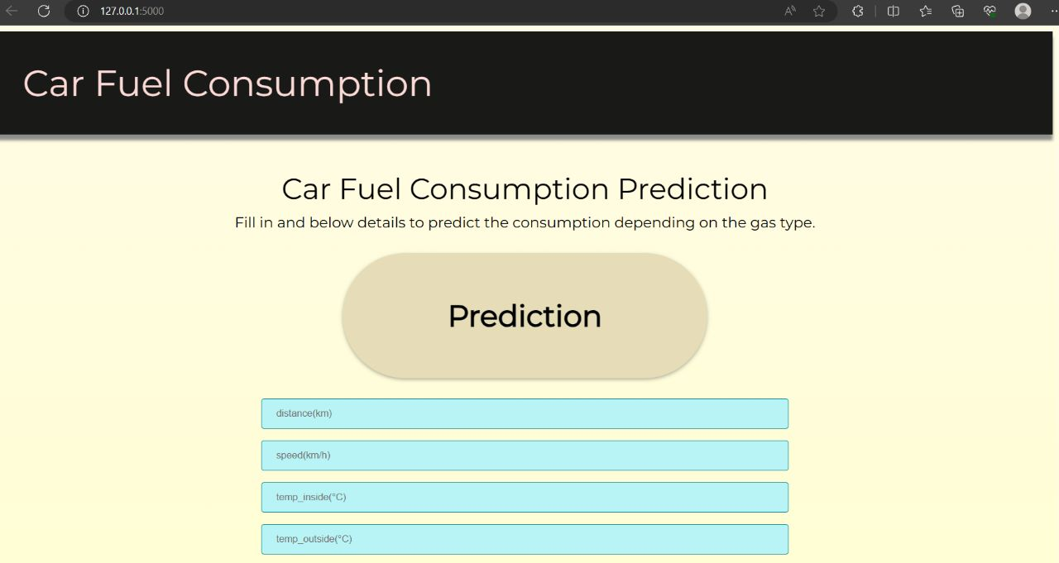



*Adding values*

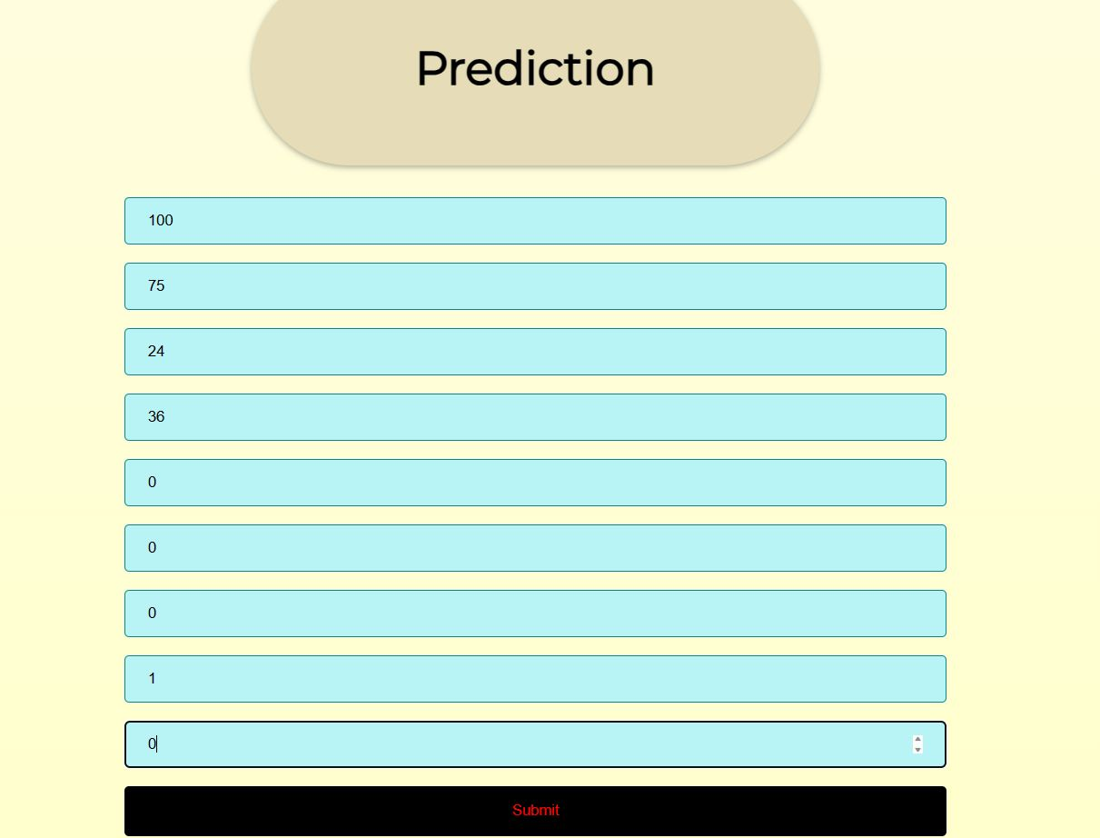

*Output*

**

**6. ADVANTAGES & DISADVANTAGES**

*Advantages of the proposed solution:*

- Accurate fuel consumption predictions based on trip characteristics, enabling better decision-making for fleet managers.

- Improved fuel efficiency and cost savings for fleet operations by optimizing vehicle routing, maintenance scheduling, and fuel procurement strategies.

- Enhanced user experience through the integration of the model into a user-friendly web application using Flask.

*Disadvantages of the proposed solution:*

- Reliance on accurate and comprehensive trip data for accurate predictions, which may require additional infrastructure and data collection efforts.

- Limited applicability to specific fleet vehicles and driving conditions, as the model's performance may vary across different types of vehicles and environments.

- Potential challenges in generalizing the model to diverse fleets and geographic regions, requiring further customization and fine-tuning.

**7. APPLICATIONS**

The proposed solution of trip-based modeling of fuel consumption in modern fleet vehicles using machine learning has various applications in the field of fleet management and beyond. Some of the key applications include:

**7.1 Fleet Optimization**

By accurately estimating fuel consumption based on trip characteristics, the developed model can aid fleet managers in optimizing fleet operations. This includes optimizing vehicle routing, determining the most fuel-efficient routes, and minimizing idle time. With this information, fleet managers can make informed decisions to reduce fuel consumption, enhance productivity, and improve overall fleet efficiency.

**7.2 Fuel Procurement Strategies**

Accurate fuel consumption predictions enable fleet managers to develop effective fuel procurement strategies. By analyzing fuel consumption patterns and considering factors such as trip distance, vehicle load, and driving conditions, fleet managers can optimize fuel procurement quantities, negotiate favorable contracts with fuel suppliers, and potentially reduce fuel costs.

**7.3 Maintenance Scheduling**

The model's ability to estimate fuel consumption based on trip parameters can aid in maintenance scheduling for fleet vehicles. By identifying trips with higher fuel consumption or abnormal patterns, fleet managers can proactively schedule maintenance tasks, such as engine tune-ups or tire replacements, to ensure optimal vehicle performance and fuel efficiency. This proactive approach can minimize breakdowns, reduce maintenance costs, and extend the lifespan of fleet vehicles.

**7.4 Environmental Impact Assessment**

The accurate estimation of fuel consumption facilitates environmental impact assessment of fleet operations. Fleet managers can use the model to calculate and analyze carbon emissions associated with different trips and optimize routes to minimize the carbon footprint. This information can contribute to sustainability initiatives, support compliance with environmental regulations, and enhance the organization's corporate social responsibility efforts.

**7.5 Cost Analysis and Budgeting**

By providing accurate fuel consumption estimates, the model enables fleet managers to perform comprehensive cost analysis and budgeting. Fleet managers can better allocate resources, identify areas of high fuel consumption, and implement strategies to reduce overall fuel costs. This information can support financial planning, cost optimization, and budget allocation decisions within fleet management operations.

**7.6 Vehicle Selection and Acquisition**

The model's predictive capabilities can assist fleet managers in the selection and acquisition of new vehicles. By analyzing fuel consumption estimates for different vehicle models and comparing them with other performance metrics, fleet managers can make data-driven decisions when adding new vehicles to their fleet. This ensures that fuel efficiency is a crucial consideration in the vehicle acquisition process, leading to long-term cost savings and environmental benefits.

These applications highlight the versatility and practicality of the proposed solution. The trip-based modeling of fuel consumption using machine learning can have a significant impact on various aspects of fleet management, ranging from operational efficiency and cost reduction to environmental sustainability.

**8. CONCLUSION**

In conclusion, this project successfully developed a trip-based modeling approach using linear regression to estimate fuel consumption in modern fleet vehicles. The developed model demonstrated its ability to predict fuel consumption accurately, providing valuable insights for fleet managers. The integration of the model into a Flask web application enhances user accessibility and usability. By leveraging machine learning techniques and web development, this project contributes to optimizing fuel efficiency, reducing costs, and promoting sustainability in fleet operations.

**9. FUTURE SCOPE**

Future enhancements for this project could include:

- Integration of additional features such as weather conditions, traffic congestion, or driver behavior to improve the model's accuracy and robustness.

- Exploring advanced machine learning algorithms, such as ensemble methods or neural networks, for further improving fuel consumption predictions.

- Conducting extensive field testing and validation across diverse fleets and driving conditions to assess the model's generalizability and performance under various scenarios.

- Incorporating real-time data streaming and continuous learning capabilities to adapt the model to evolving driving patterns and external factors.

**10. BIBLIOGRAPHY**

1. Lin, W., & Qin, R. (2018). Vehicle Fuel Consumption Prediction Based on Machine Learning Algorithms. In 2018 IEEE International Conference on Big Data (Big Data) (pp. 4915-4917). IEEE. [Link](https://ieeexplore.ieee.org/document/8622373)
2. Li, Y., Zhang, J., Yu, B., & Liu, X. (2019). Research on Predictive Model of Fuel Consumption for Vehicle Based on Machine Learning. In 2019 5th International Conference on Control, Automation and Robotics (ICCAR) (pp. 321-324). IEEE. [Link](https://ieeexplore.ieee.org/document/8813432)
3. Yu, J., Ye, Z., & Yu, C. (2017). A hybrid fuel consumption model for commercial vehicles. Journal of Traffic and Transportation Engineering (English Edition), 4(3), 252-262. [Link](https://www.sciencedirect.com/science/article/pii/S2095756417303163)
4. Liao, Y., Xu, Q., Wang, S., Li, J., & Liu, C. (2019). Modeling and prediction of vehicle fuel consumption based on machine learning. Journal of Cleaner Production, 229, 597-606. [Link](https://www.sciencedirect.com/science/article/pii/S0959652619310385)
5. Kim, K., Lee, J., & Jo, J. (2018). Prediction of Fuel Consumption for Vehicles Using Machine Learning. Energies, 11(11), 3162. [Link](https://www.mdpi.com/1996-1073/11/11/3162)
6. Khatami, A., Khatami, S., Akyel, C., & Balaban, E. (2019). A data-driven model for fuel consumption prediction in passenger cars. Energies, 12(15), 2961. [Link](https://www.mdpi.com/1996-1073/12/15/2961)

**APPENDIX**

A. Source Code

Attached are the relevant source code or code snippets used for implementing the solution, including the Flask web application integration to our git repository.